2. Timeline Chart / Gantt Chart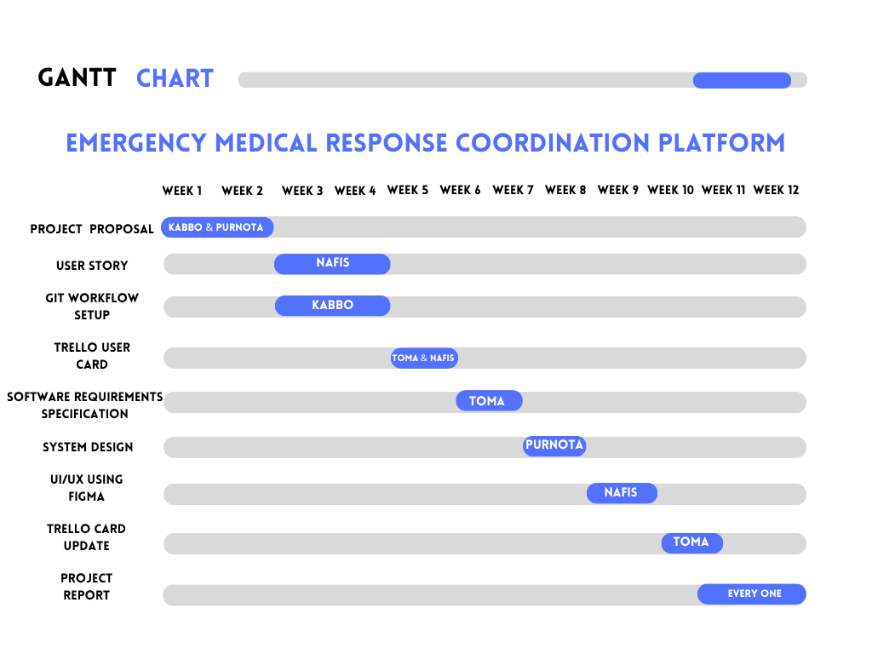
Explanation:
This project schedule outlines a 12-week development lifecycle structured across sequential phases of planning, design, and final documentation. It begins with the Project Proposal at Week 1 for 2 weeks, followed concurrently by User Story and Git workflow Setup starting in Week 3, and transitions into tracking via Trello User Card in Week 5. The middle phase focuses on technical design and prototyping, handling the Software Requirements Specification, System Design, and UI / Wireframe Design using Figma sequentially from Weeks 6 through 8, alongside a Trello Card Update in Week 9. The project concludes with the Project Report starting in Week 10 and running through Week 12 to wrap up the overall deliverables.

